

**Bangladesh University of Business and Technology**

**Report**

**On**

**Crime Report**

Submitted By

Md. Ashraful Hossain ID: 18192103137

Sk. Md. Rumman ID: 18192103138

Arup Raton Chowdhury ID: 18192103155

Arman Hossain ID: 18192103156

Rakibul Hasan Shafin ID: 18192103165

**Submitted To:**

Maksudul Mimon

Lecturer

Department of Computer Science and Engineering

Bangladesh University of Business and Technology

**Table of Contents**

1. Abstract
2. Introduction
3. Implementation
4. Code

**Abstract**

The crimes happening around awakened we to go for the safety issues, so new websites have been developed to provide security systems online that can be operated easily. Crime reporting helps prevent the law enforcement agencies from the manual work. It can be handled by police and other authorities. Moreover it will prevent the delay

**Introduction**

Crime reporting has long been a central part of news coverage in free press societies, because crime stories are usually newsworthy. The need for good record-keeping and information-sharing practices has taken on great significance in today's global environment. Not only do well-organized records provide important internal information (i.e., business operations and case management support—not to forget the official memory of an agency's investigations), law enforcement agencies are now required to communicate agency-to-agency and across continents to protect the Nation’s citizens. Nothing is more necessary to accomplishing that mission than having accessibility to accurate and timely records. Calls for service records and investigative, arrest, criminal identification, detention, and even civil records hold data that by themselves mean little; however, once pieced together with information from other jurisdictions, the result can help with all levels of investigations and aid in safeguarding the Nation.

**Implementation**

Main Table

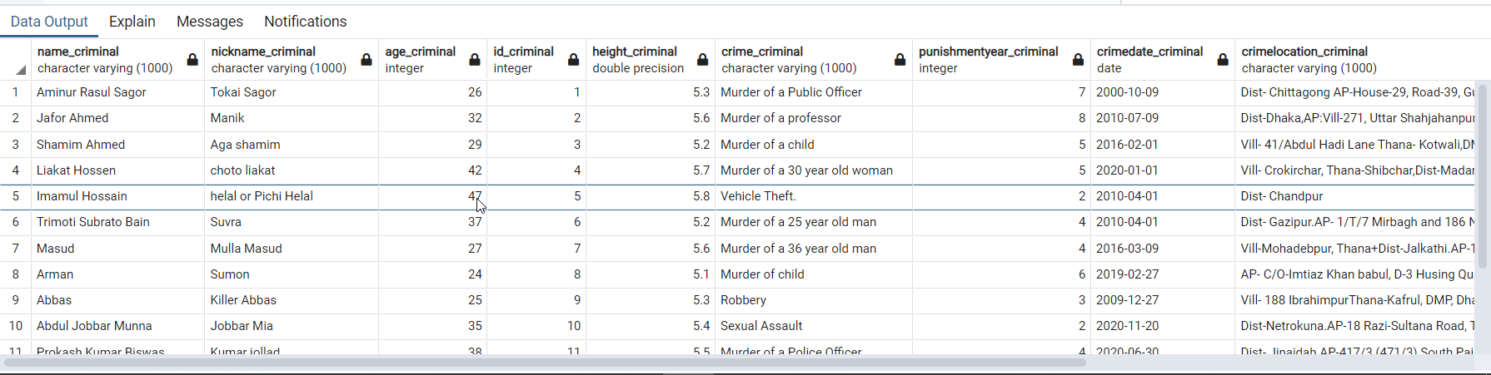

Table after partition 1

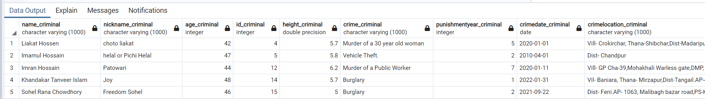

Table After partition 2

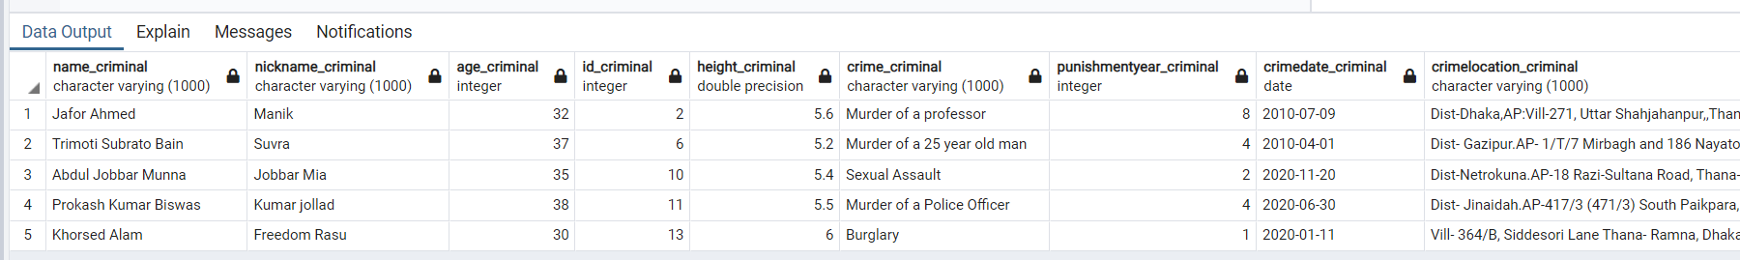

Table after partition 3

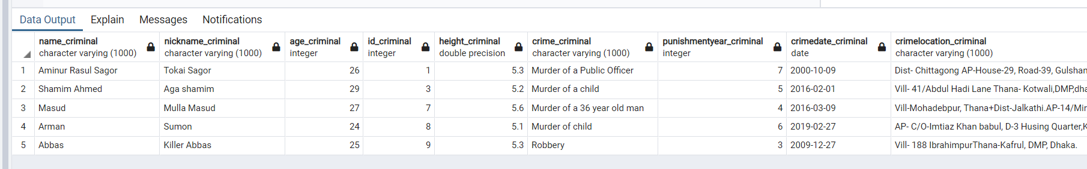

Output:

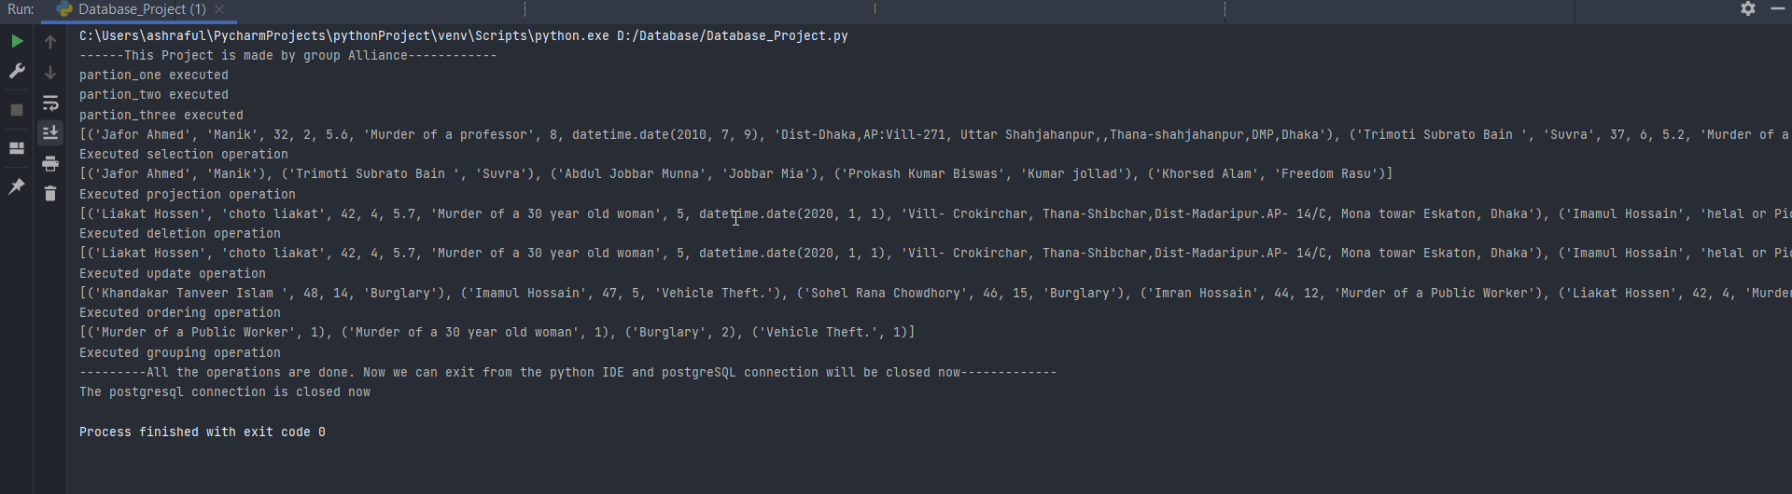

**Code:**

import psycopg2

from psycopg2 import Error

print("------This Project is made by group Alliance------------")

try:

conn = psycopg2.connect(dbname = 'Crime Report', user = 'postgres',password = '1234',port ='5432')

cursor = conn.cursor()

cursor.execute('DROP TABLE IF EXISTS report')

#We have created our main table (report) here

table = ''' create table report(name_criminal varchar(1000),nickname_criminal varchar(1000) ,age_criminal int,id_criminal int, height_criminal float, crime_criminal varchar(1000),punishmentyear_criminal int,crimedate_criminal date,crimelocation_criminal varchar(1000))'''

cursor.execute(table)

#We have inserted table data here

insert = ''' insert into report (name_criminal,nickname_criminal,age_criminal,id_criminal,height_criminal,crime_criminal,punishmentyear_criminal,crimedate_criminal,crimelocation_criminal)

values(%s,%s,%s,%s,%s,%s,%s,%s,%s)'''

# Criminal Data are given here. We have taken random info from different website and used some imaginary names

values = [('Aminur Rasul Sagor','Tokai Sagor', 26,1, 5.3, 'Murder of a Public Officer', 7,'2000/10/09','Dist- Chittagong AP-House-29, Road-39, Gulshan, DMP,Dhaka. (AP:Vill- 412 Askuna, thana-dakhin Khan, Dhaka'),

('Jafor Ahmed','Manik',32,2,5.6,'Murder of a professor',8,'2010/07/09','Dist-Dhaka,AP:Vill-271, Uttar Shahjahanpur,,Thana-shahjahanpur,DMP,Dhaka'),

('Shamim Ahmed','Aga shamim',29,3,5.2,'Murder of a child',5,'2016/02/01','Vill- 41/Abdul Hadi Lane Thana- Kotwali,DMP,dhaka.'),

('Liakat Hossen','choto liakat' ,42,4, 5.7, 'Murder of a 30 year old woman', 5,'2020/01/01','Vill- Crokirchar, Thana-Shibchar,Dist-Madaripur.AP- 14/C, Mona towar Eskaton, Dhaka'),

('Imamul Hossain', 'helal or Pichi Helal', 47,5, 5.8, 'Vehicle Theft.', 2,'2010/04/01','Dist- Chandpur'),

('Trimoti Subrato Bain ','Suvra',37,6,5.2,'Murder of a 25 year old man',4,'2010/04/01','Dist- Gazipur.AP- 1/T/7 Mirbagh and 186 Nayatola,Mogbazar, Ramna, DMP Dhaka.'),

('Masud', 'Mulla Masud',27,7,5.6,'Murder of a 36 year old man',4,'2016/03/09','Vill-Mohadebpur, Thana+Dist-Jalkathi.AP-14/Mirbagh, Thana-Ramna,DMP,Dhaka .'),

('Arman','Sumon',24,8,5.1,'Murder of child',6,'2019/02/27','AP- C/O-Imtiaz Khan babul, D-3 Husing Quarter,Kazi Nazrul Islam road, PS-MohammadpurDMP, Dhaka .'),

('Abbas','Killer Abbas',25,9,5.3,'Robbery',3,'2009/12/27','Vill- 188 IbrahimpurThana-Kafrul, DMP, Dhaka.'),

('Abdul Jobbar Munna','Jobbar Mia',35,10,5.4,'Sexual Assault',2,'2020/11/20','Dist-Netrokuna.AP-18 Razi-Sultana Road, Thana-Mohammadpur, DMP, Dhaka.'),

('Prokash Kumar Biswas','Kumar jollad',38,11,5.5,'Murder of a Police Officer',4,'2020/06/30','Dist- Jinaidah.AP-417/3 (471/3) South Paikpara,PS-Mirpur, DMP, Dhaka.'),

('Imran Hossain','Patowari',44,12,6.2,'Murder of a Public Worker',7,'2020/01/11','Vill- GP Cha-39,Mohakhali Warless gate,DMP, Dhaka .'),

('Khorsed Alam','Freedom Rasu',30,13,6.0,'Burglary',1,'2020/01/11','Vill- 364/B, Siddesori Lane Thana- Ramna, Dhaka.(AP-21 Siddesori Lane Building No-03, Flat-104 eastern Plaza, Ramna, DMP, Dhaka).'),

('Khandakar Tanveer Islam ','Joy',48,14,5.7,'Burglary',1,'2022/01/31','Vil- Baniara, Thana- Mirzapur,Dist-Tangail.AP-438/16 (43/R/16) Indira Road,PS-Tajgaon, DMP, Dhaka.'),

('Sohel Rana Chowdhory','Freedom Sohel',46,15,5.0,'Burglary',2,'2021/09/22','Dist- Feni.AP- 1063, Malibagh bazar road,PS-Khilgaon, DMP, Dhaka.')

]

for v in values:

cursor.execute(insert,v)

conn.commit()

# We have started our table partition from here

drop_one = 'drop table if exists partition_one'

cursor.execute(drop_one)

drop_two = 'drop table if exists partition_two'

cursor.execute(drop_two)

drop_three = 'drop table if exists partition_three'

cursor.execute(drop_three)

conn.commit()

partition_one = '''create table partition_one as (select * from report where age_criminal> 20 and age_criminal< 30)'''

cursor.execute(partition_one)

print('partion_one executed')

partition_two = '''create table partition_two as (select * from report where age_criminal >=30 and age_criminal< 40)'''

cursor.execute(partition_two)

print('partion_two executed')

partition_three = '''create table partition_three as (select * from report where age_criminal >=40 and age_criminal< 50)'''

cursor.execute(partition_three)

print('partion_three executed')

conn.commit()

#We have started performing our queries

#insertion

# insert = ''' insert into report (name_criminal,nickname_criminal,age_criminal,id_criminal,height_criminal,crime_criminal,punishmentyear_criminal,crimedate_criminal,crimelocation_criminal)

# values(%s,%s,%s,%s,%s,%s,%s,%s,%s)'''

#

# data = ('Kala Jahangir', 'Kala Manik', 40 ,16, 5.7, 'Vehicle Theft.', 2,'2011/04/01','Dist-Bogra.A/P-131/1 Adarsha palli IbrahimpurThana-Kafrul, dhaka.')

# cursor.execute(insert, v)

#selection

cursor.execute('select * from partition_two where height_criminal< 5.7')

print(cursor.fetchall())

print('Executed selection operation')

#projection

cursor.execute('select name_criminal, nickname_criminal from partition_two')

print(cursor.fetchall())

print('Executed projection operation')

# deletion

cursor.execute("delete from partition_three where age_criminal= 35 ")

cursor.execute('select * from partition_three')

print(cursor.fetchall())

print('Executed deletion operation')

# update

cursor.execute("update partition_three set height_criminal = 5.5 where age_criminal= 26")

cursor.execute('select * from partition_three')

print(cursor.fetchall())

print('Executed update operation')

# ordering

cursor.execute('select name_criminal,age_criminal,id_criminal,crime_criminal from partition_three order by age_criminal desc')

print(cursor.fetchall())

print('Executed ordering operation')

# grouping

cursor.execute('select crime_criminal,count(punishmentyear_criminal) from partition_three group by crime_criminal')

print(cursor.fetchall())

print('Executed grouping operation')

print('---------All the operations are done. Now we can exit from the python IDE and postgreSQL connection will be closed now-------------')

except (Exception, Error) as error:

print('There are some problem : ',error)

finally:

if (conn):

cursor.close()

conn.close()

print('The postgresql connection is closed now')